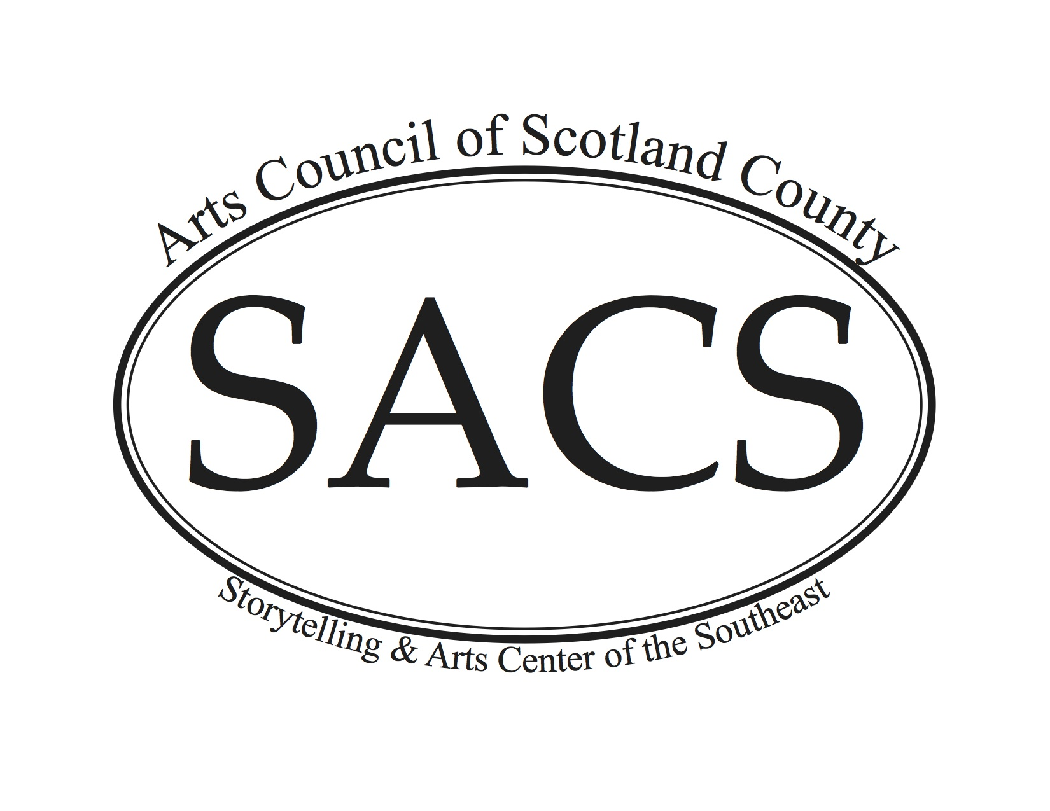

Board of Directors  Jonathon Lewis, Chair  Sheila Swift, 2nd Vice Chair  Terry Gallman, Treasurer  Richard Gay, Secretary  Joseph Begnaud  Kyle Bethel  Tabatha Burk  Crawford Fitch  Dayonna Johnson  Ann Kurtzman  Brynna McMillan  Effie McGill  Dora Sharber  Myra Stone  Staff  Candice Manning  Office Administrator | The Arts Council of Scotland County would like to invite you to take part in our upcoming Spring Fest 2019 – which now includes a brand new Laurinburg After 5 and Parks and Rec Movie in the Garden (on Friday night) and the downtown Spring Arts Fest and the Scotland Memorial Foundation FunD Run (on Saturday)! We are excited to bring our downtown community together again and show off the dedication and hard work of those people who believe in the arts and believe in downtown! As an exhibitor/vendor, you are a very important piece to this event and we want you there!  For your information, the event details are provided below.  Date of the Spring Art Festival: Saturday, April 27, 2019  Location: Downtown Laurinburg! Vendors will be located on Main Street and possibly side streets depending on number of applicants (Roper, Cronly)  Contact person/phone number: Terry Gallman (text is acceptable) @ 910-474-2305  or call Candice Manning @ 910-277-3599  Suggested arrival time to set up booth: 8:00 am  Spring Fest hours: 10 am to 5 pm  Estimated number of attendees: 2500  Indoors/outdoors: Outdoors  Size of booth area: approx.15x15  Vendors may bring tents for their sites. Vendors should also bring their own tables, chairs and trashcans with lids.  Participation fee: $50(crafts) $65 Food (paid to the Arts Council of Scotland County) Fee has risen by $15 due to how huge an event this has grown to! This fee helps support our non-profit mission. We received such positive feedback after Christmas on Main, if you participated we hope you fared well!  If you would to participate, please complete the enclosed Vendor Application Form and return it by April 19, 2019 to the Arts Council of Scotland County, P.O. Box 2154 Laurinburg NC 28352 or to officemanager@storyartscenter.org. We encourage you to pass this information along to other vendors that you know that may be interested in this event. The more, the merrier!  Thank you for considering participation in the Spring Art Festival!  Sincerely,  Candice Manning and Terry Gallman  Vendor Contact  Spring Art Festival 2019
Spring Art Festival Vendor Application Form
Saturday April 27, 2019

Please register as early as possible to insure space availability. Deadline – April 19, 2019.

Booth Spaces
- 15 X 15 foot spaces are available. Vendors are responsible for setting up their own space.
- No electricity provided.
- Generators are allowed.
Food Booths:
- No alcoholic beverages are allowed on the premises.
- Vendors are responsible for securing health permits and meeting health regulations.
- Vendors are responsible for securing appropriate fire extinguishers as required by Fire Inspector.
Craft Booths:
- Crafts should be of high quality. The committee reserves the right to refuse the sale of any items it deems objectionable.
- Consumable crafts such as jellies, soaps, honey, etc. are welcomed and encouraged!
Non-Profit Booths:
- Educational materials or activities only. No sales may take place at your booth.

You may set up on starting at 8:00 a.m. The festival begins at 10:00 a.m.

Please check vendor type and fill out application below:

_____ FOOD VENDOR $65.00

List foods to be served: ________________________________________________________________

_____ CRAFT VENDOR $50.00

Description of Craft (Include pictures of your craft as required):_______________________________

_____ NON-PROFIT FREE
____________________________________________________________________________________

Name: _________________________________________________________________

Business Name: _________________________________________________________

Address: _______________________________________________________________

Telephone: ______________________________________________________________

Email: _________________________________________________________________

NC Sales Tax Number: ____________________________________________________

The Arts Council of Scotland County and any entity thereof and/or the City of Laurinburg will not be responsible for accident or loss during the period of the festival. This is agreed to vendors as signed here:

Signature of Vendor:____________________________________ Date:______________

Mail checks to: SACS, PO Box 2154, Laurinburg, NC 28353

