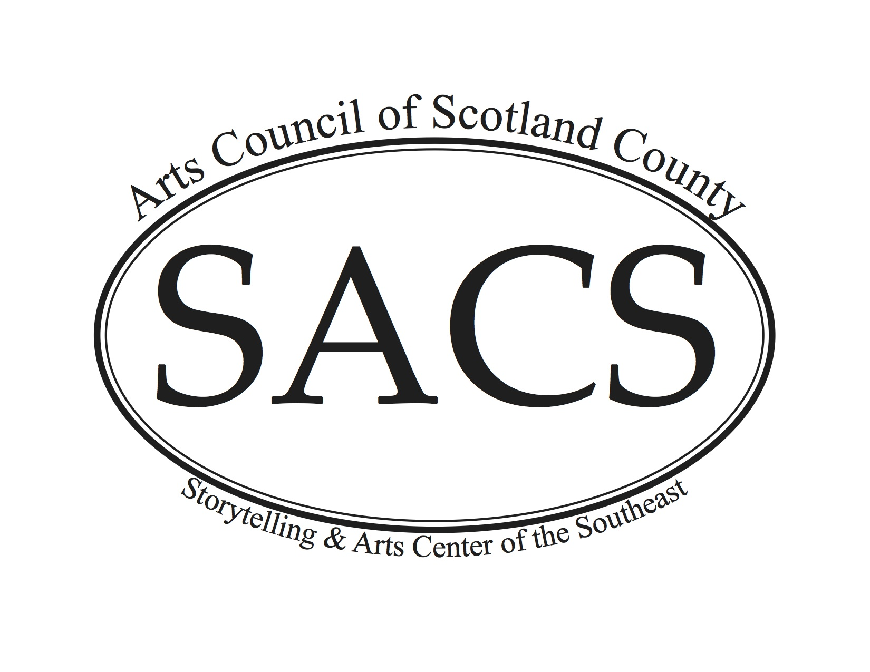
Summer Art Camp 2017
Registration Form

Participant Name: _____________________________________ Age __________
Participant Allergies: _________________________________________________
Parent/Guardian Name: _______________________________________________
Mailing Address: ____________________________________________________
Phone Number: ________________ Email: ________________________________
Emergency Contact: _____________________________ Phone: _______________
Make Checks Payable to SACS
Card Type MC ____ Visa ____ Disc ____ AMEX ____
Card Number ______________________________________
Expiration Date ____/____ CCV ____ Billing Zip Code ______

Please mark your selections:

It’s Alive! ______
Shadow Puppetry Camp
Tuesday June 20-Friday, June 23, 2017 9 am to 12 pm
$30 per camper - includes all supplies and a daily snack

Intro to Painting _____
Tuesday, June 27-Thursday, June 29, 2017 9 am to 12 pm
$30 per camper – includes all supplies and a daily snack

Each class has a minimum requirement of 6 students and is capped at 15 students and will be supervised by two instructors and one additional adult.

I agree to allow my child to participate in the activity named above by the Storytelling & Arts Center of the Southeast, Inc. I understand that my child shall abide by all center rules as a condition of participation. I am aware that there is always the chance that any activity may cause accident or injury as a direct result of participation. I also agree to assume all risks involved in my child participating in the activity. I further agree to release the Storytelling & Arts Center of the Southeast, its employees, volunteers and agents from any responsibility should an accident occur.

Parent/Guardian Signature: ________________________________ Date _____

I agree to release any pictures taken during the program to be used for promotional purposes.

Parent/Guardian Signature: ____________________ Date _____

